Cloud Computing

Submitted By: Zunaira Khatoon
Submitted To: Engr. Shoaib
Roll No: BSE-2023-074
Section: V-B
LAB 7

Task 1 — Print & filter environment variables
Step1
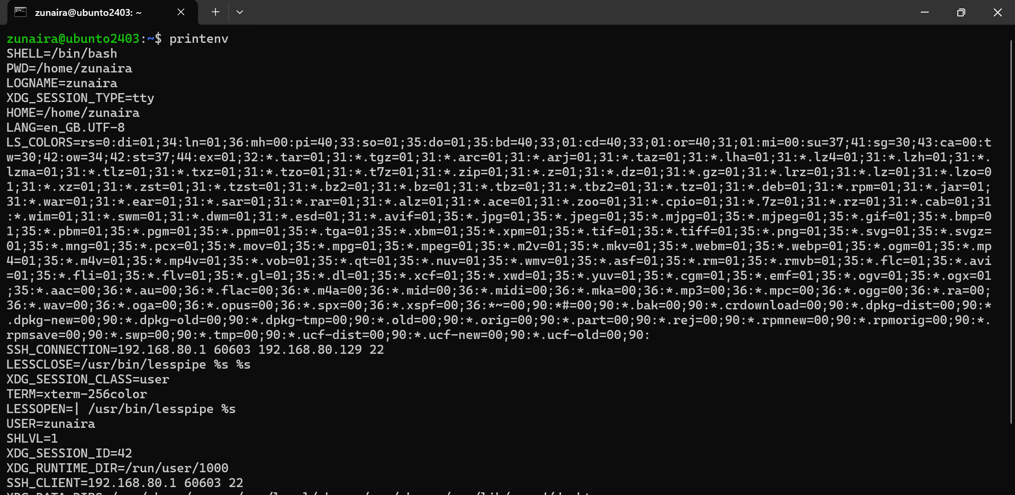
Step2
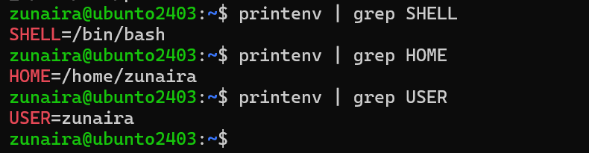
Task 2 — Export DB_* variables temporarily and observe scope
Step1
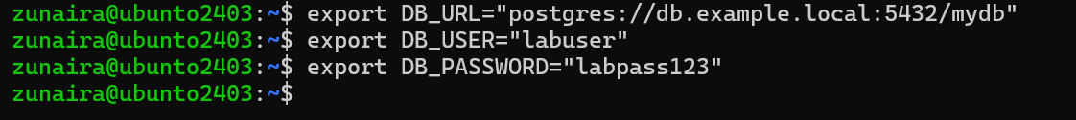
Step2
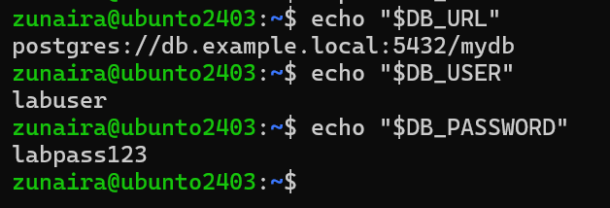
Step3
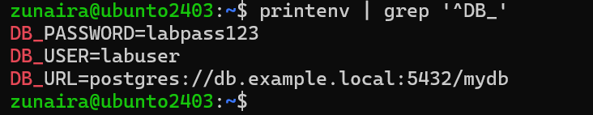
Step4
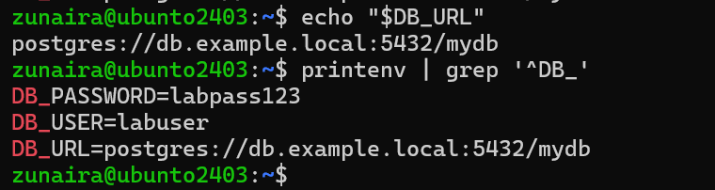
Task 3 — Make DB_* variables persistent in ~/.bashrc
Step1
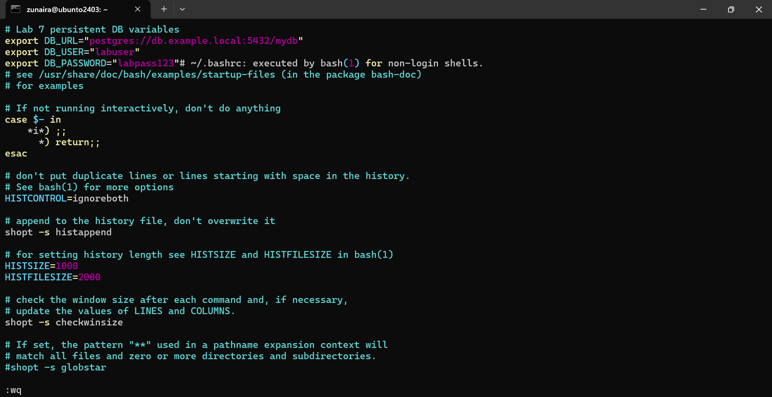
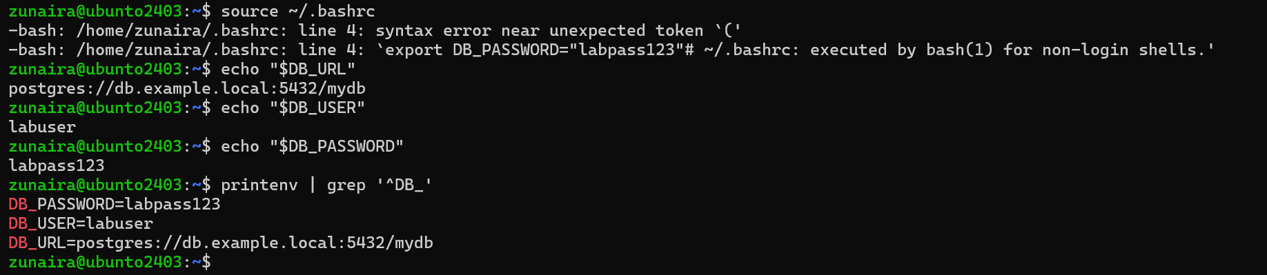
Step3
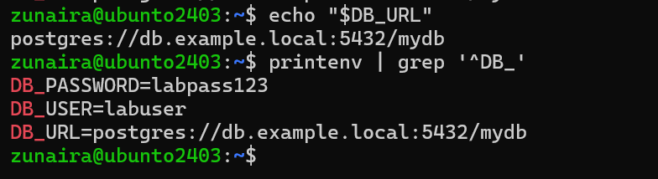
Task 4 — System-wide environment variable, welcome script, and PATH
Step1
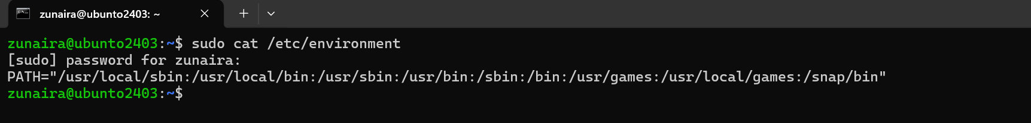
Step2
Step3
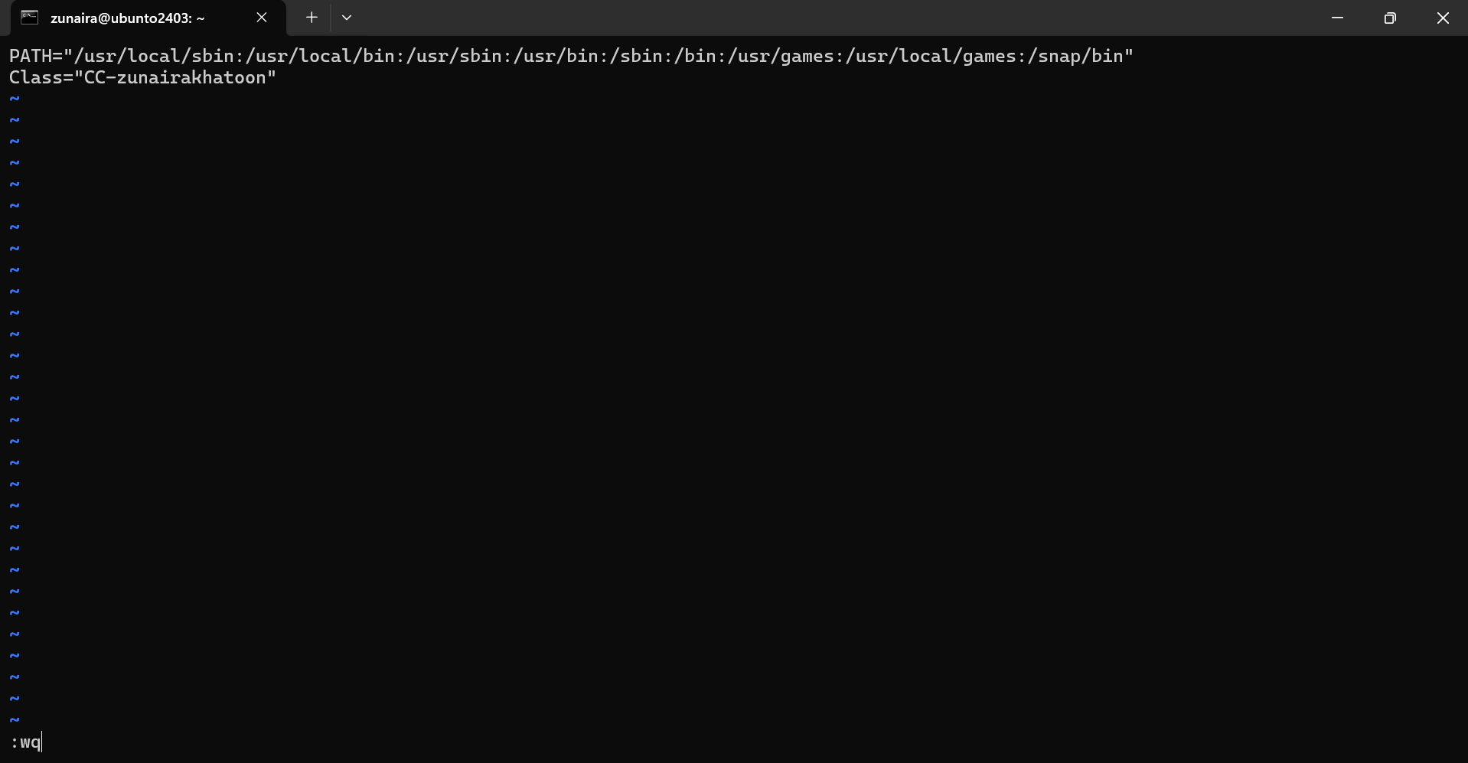
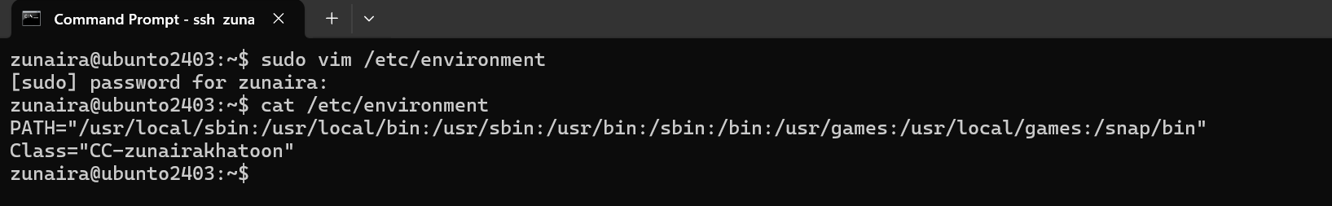
Step4
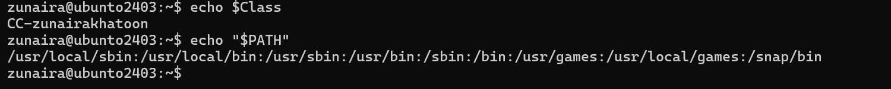
Step5
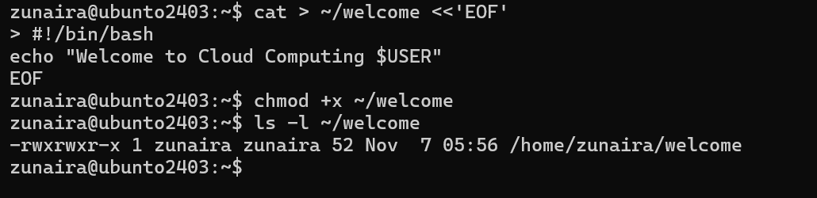
Step6
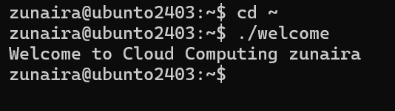
Step7
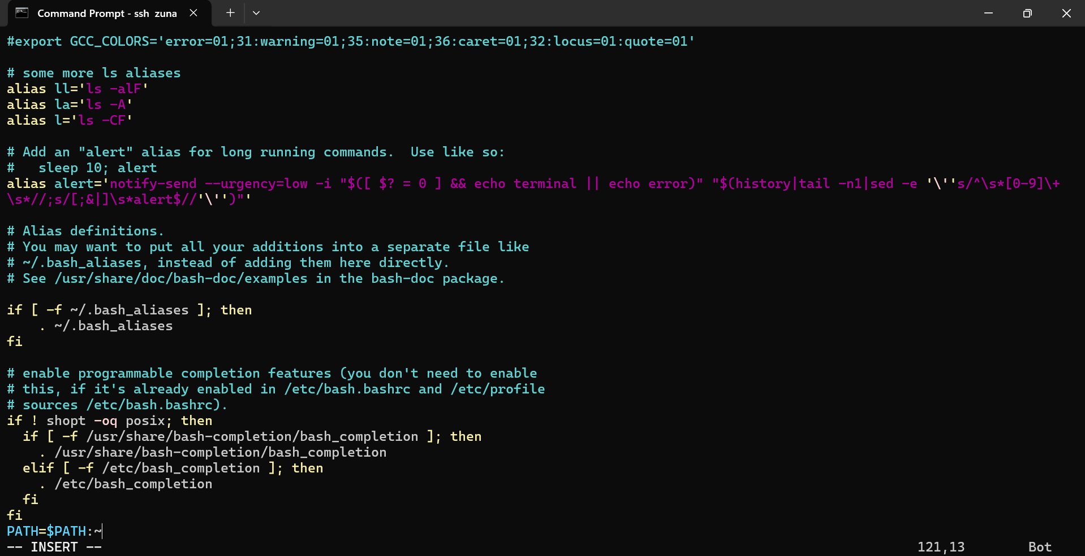
Step8
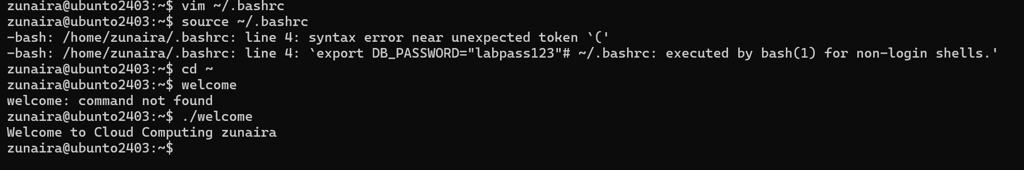
Task 5 — Block and allow SSH using ufw (firewall)
Step1
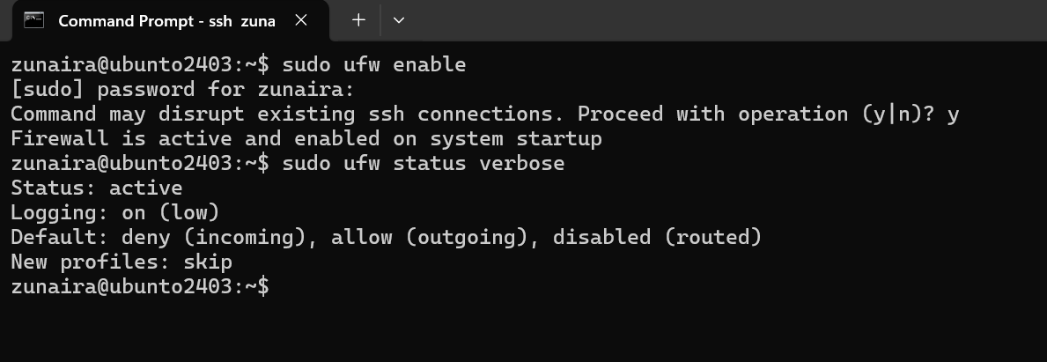
Step2
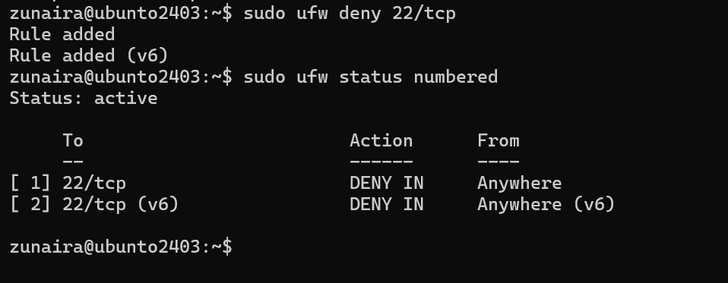
Step3
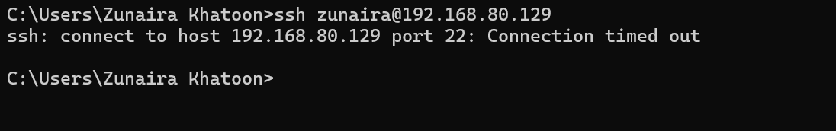
Step4
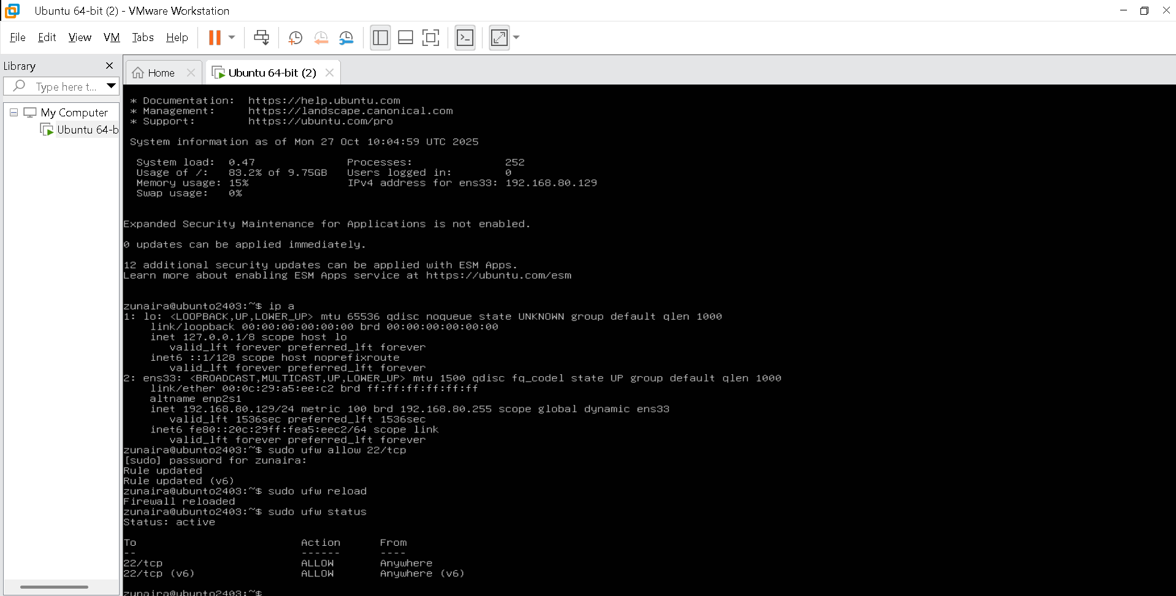
Step5
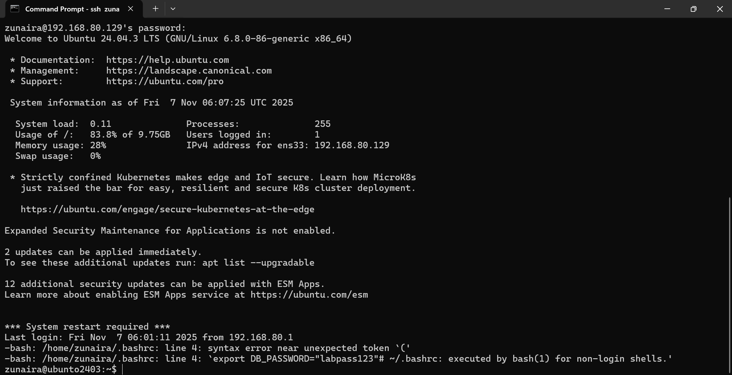
Task 6 — Configure SSH key-based login from Windows host
Step1
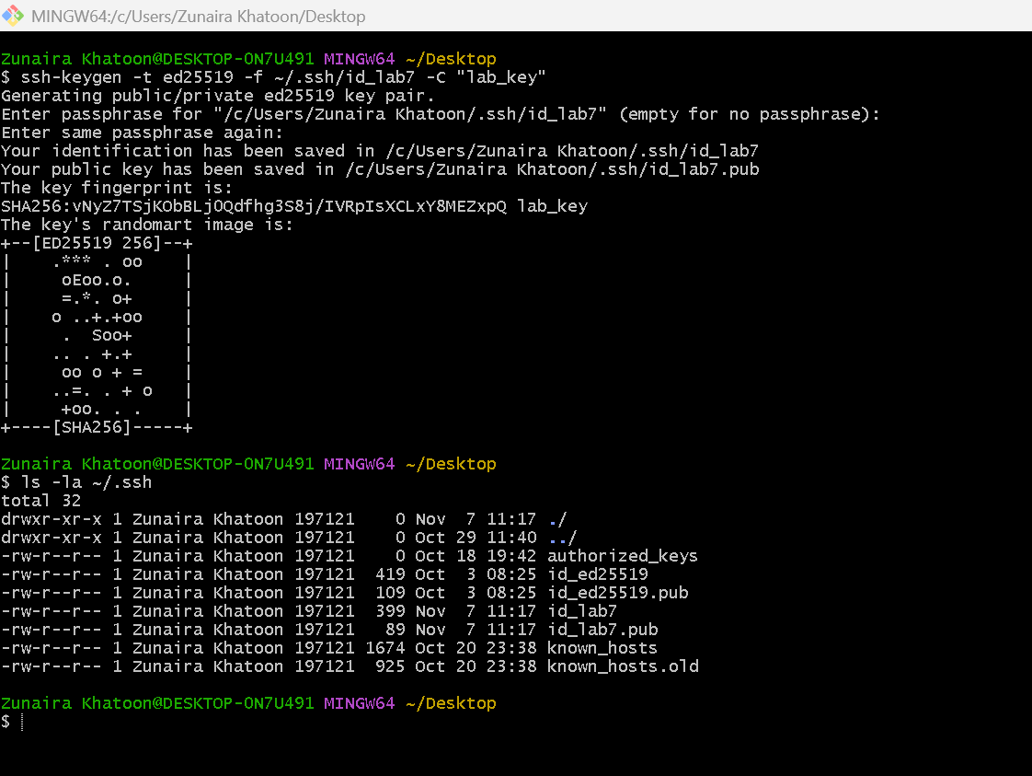
Step2
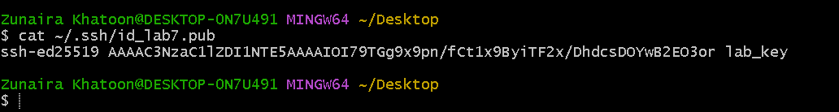
Step3
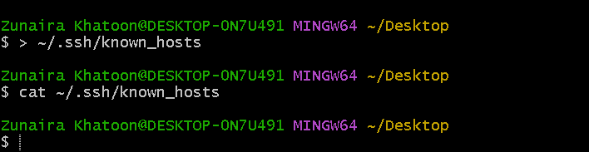
Step4
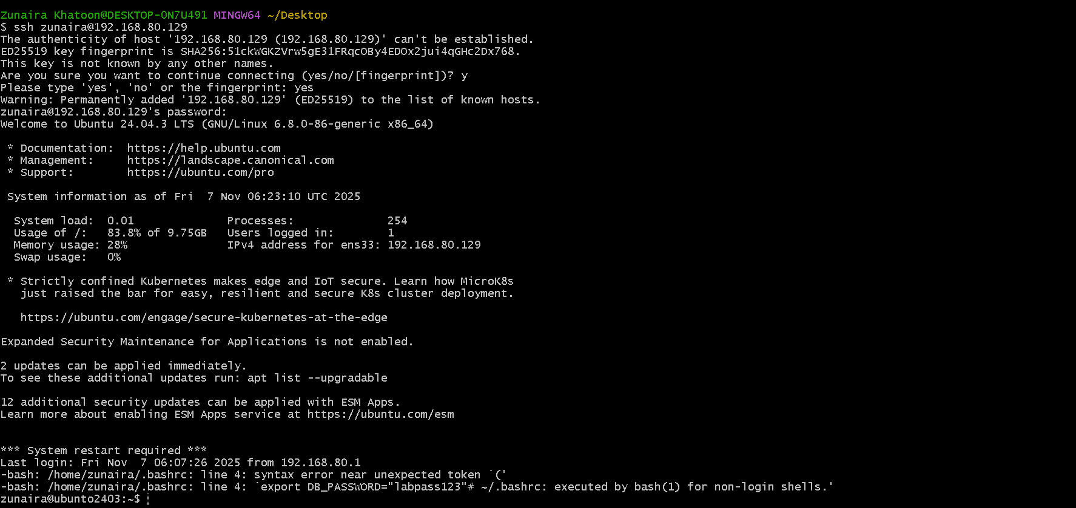
Step7
Step8
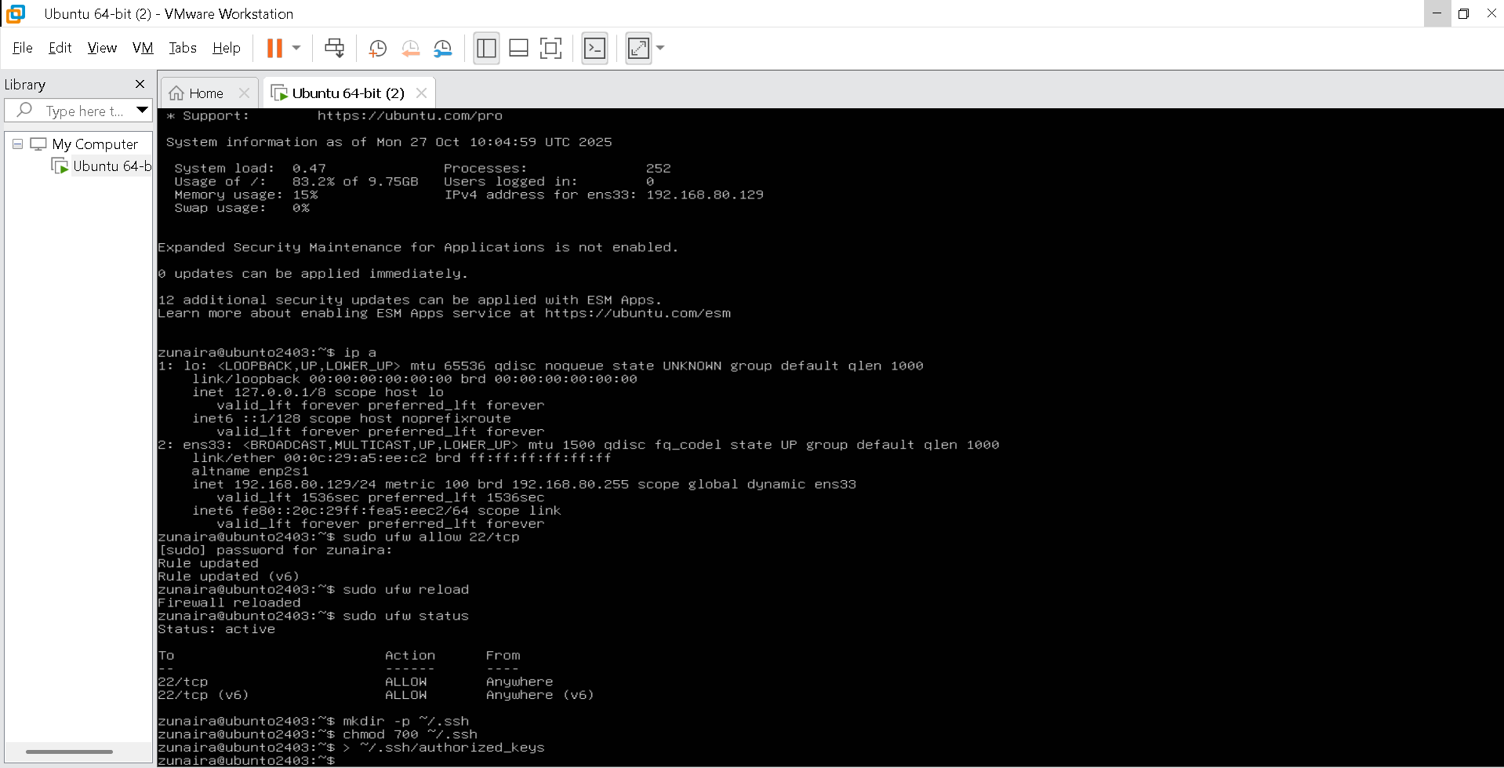
Step9
Step10
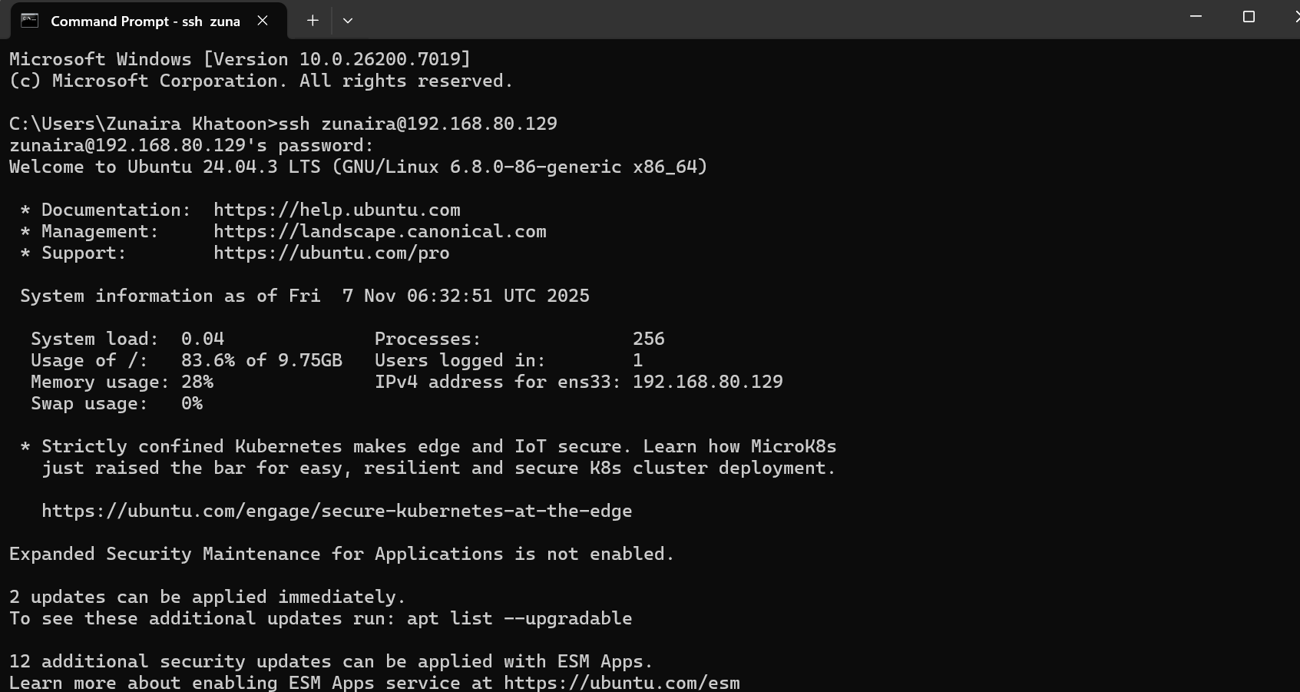
Step10
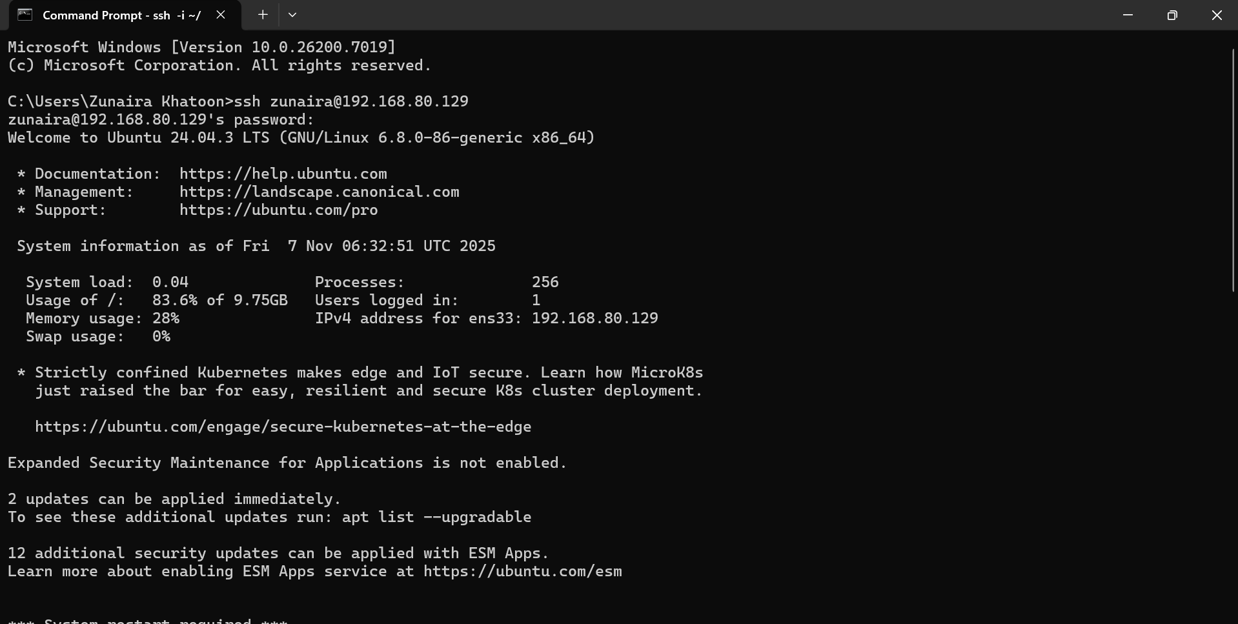
Exam Evaluation Questions
Q1: Quick Environment Audit
Step1
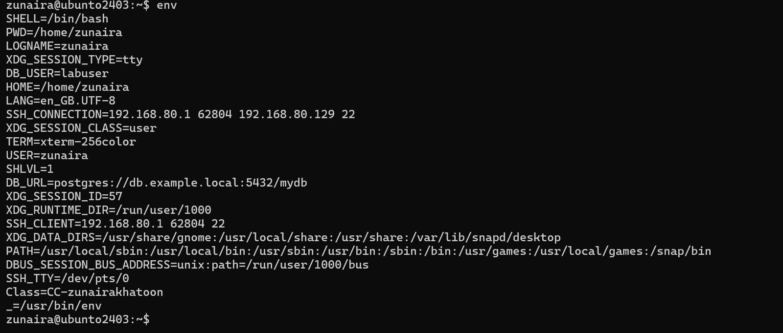
Step2
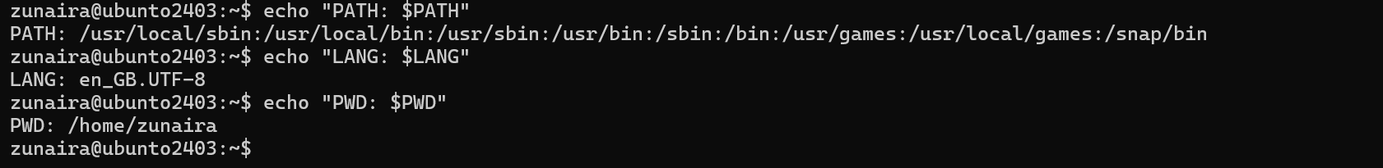
Q2 — Short-lived Student Info (session-scoped)
Step1
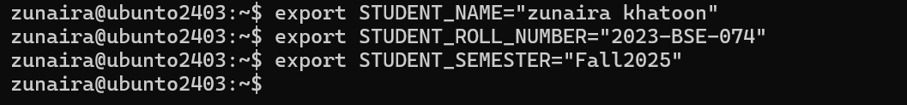
Step2
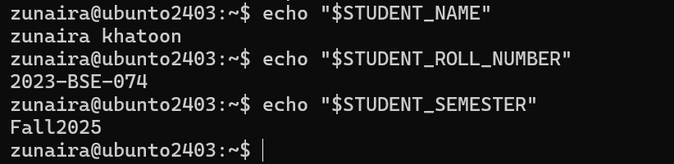
Step3
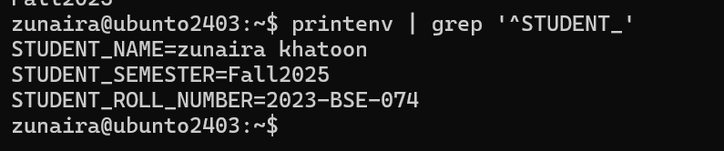
Step4
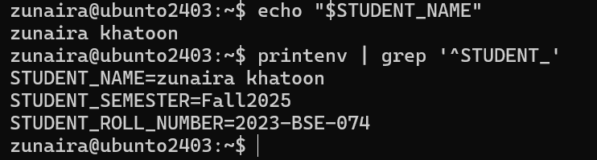
Q3: Make It Sticky (Persistence Check for Student Info)
Step1
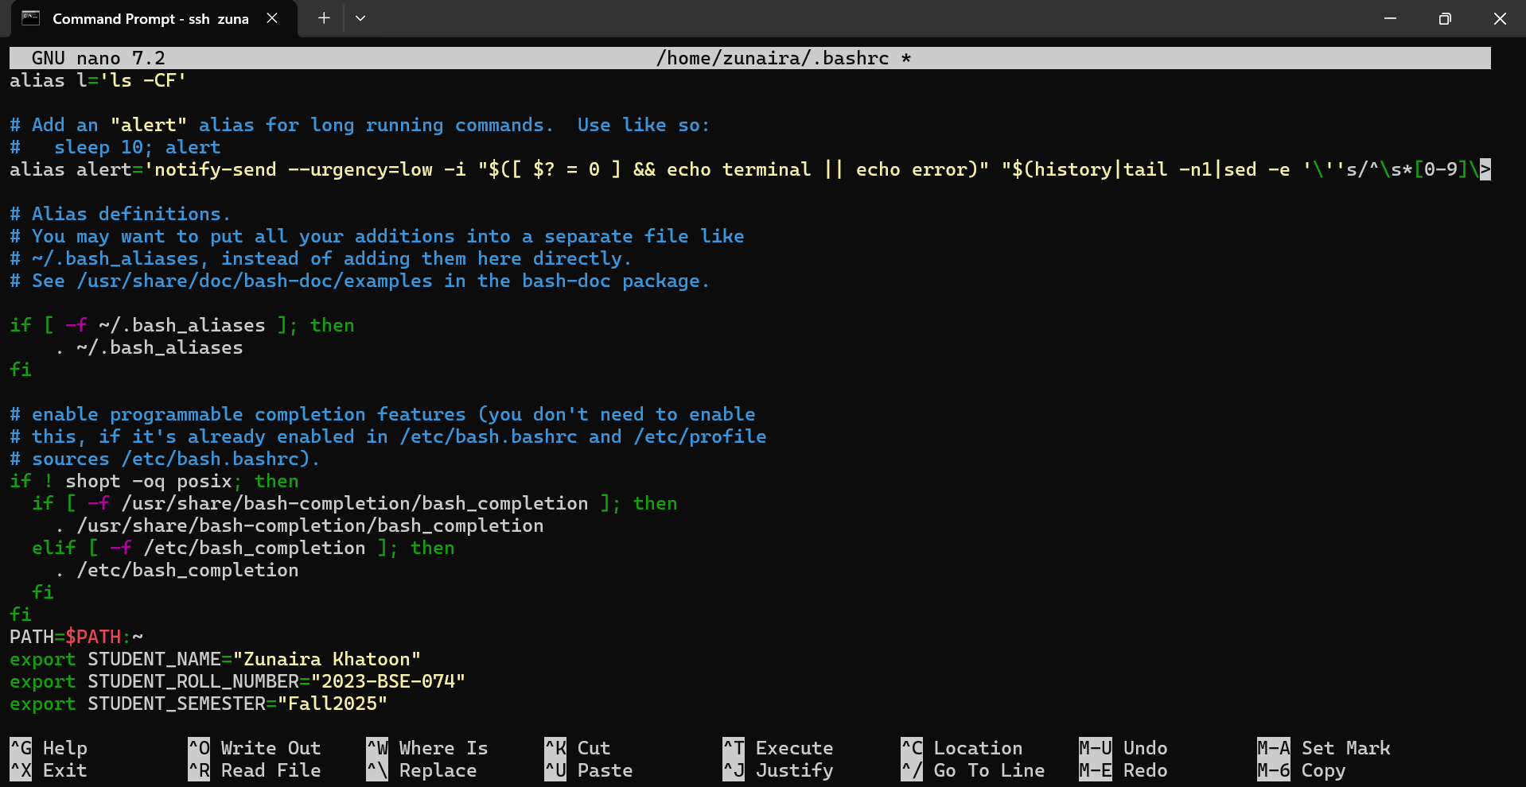
Step2
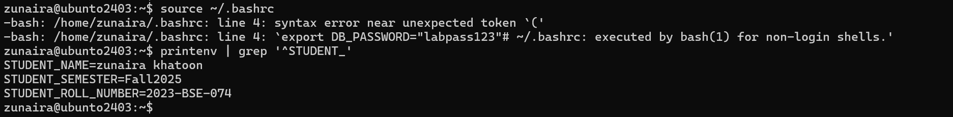
Step3
Q4: Firewall Rules: Block and Restore Ping (ICMP)
Step1
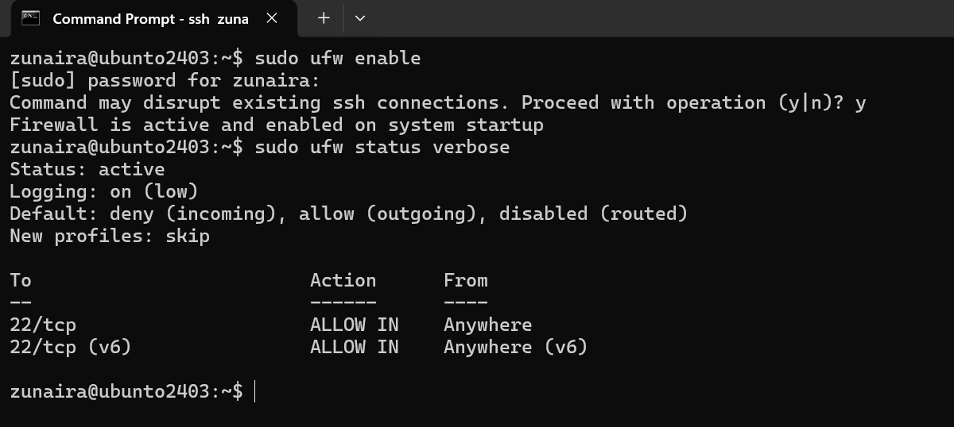
Step2
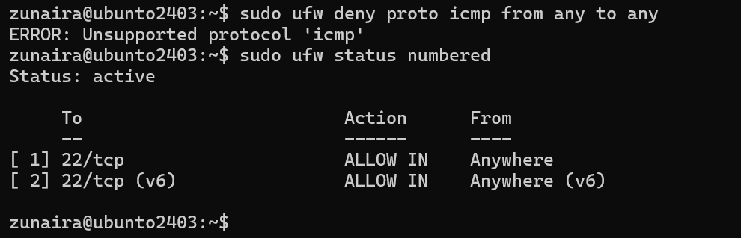
Step3
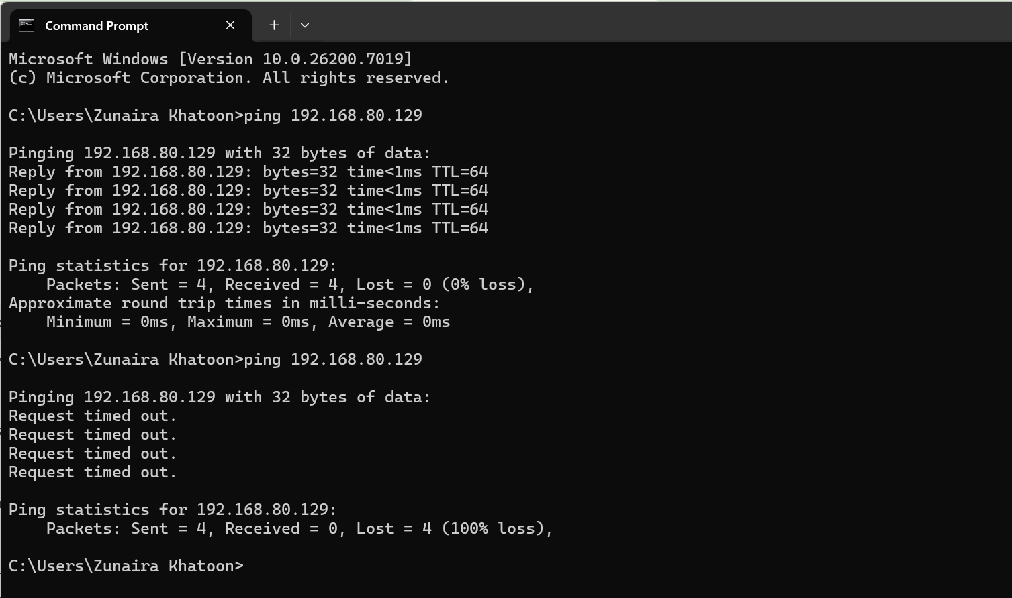
Step5
